Spring 2017 Newsletter
Brewster Schools
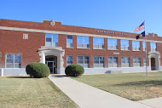

Important Dates to Remember……

May 11
6-12 Grade Activities Banquet (Pot-Luck Meal 6:30pm, Program 7:00pm CT)

May 13
JH Graduation 10am
HS Baccalaureate Service 2pm at Community Church
HS Graduation Ceremony 4pm CT
May 17
Last Day for 8th Grade

May 18
Last Day of School – FULL DAY

Keeping Up To Date….
Be sure to regularly check the daily bulletin which can be accessed at www.usd314.weebly.com for announcement and schedule changes.
A school activity calendar can be accessed on the school webpage as well.

PO Box 220 – 127 Kansas Ave. Brewster KS 67732
www.usd314.weebly.com T: 785-694-2236
Dear Students, Parents, and Patrons,
We have finally made it to the final few days of school. I would like to thank all of our families for being part of our school family this year. This has been a year that truly has flown by, it hardly seems possible that we are already thinking about summer vacations, and what next year may bring. I am excited to see what the future holds for our school, we have continued to grow throughout this year, and continue to embrace those changes. I hope everyone has a relaxing and memorable summer, it will inevitably go too fast for everyone’s liking. However, we are looking forward to another year working with you students. Enrollment for the coming ’17-’18 school year will be Tuesday August 1st. Times will be set once we get closer to that date and will be included in enrollment packets which will be mailed to each family approximately 1-2 weeks before enrollment. Again, thank you for trusting us with the education of your students this school term, have a great summer!
Sincerely,
Mr. Shea Rothchild
Superintendent/PK-12 Principal
Around the School……..……
Student Council…….Brewster Student Council is made up of members from the 7th-12th grade classes. These students have been working hard all school year long to bring service opportunities, activities and events to the school and community. The last of STUCO’s projects for this school year were hosting a meal prior to the K-6 spring music program and serving ice cream following the 7-12th grade spring music program. STUCO has already started their planning and discussion for Homecoming week next year. They are going to be changing up some of our activities here in school, and for the community. Stay tuned next fall for more news on homecoming.
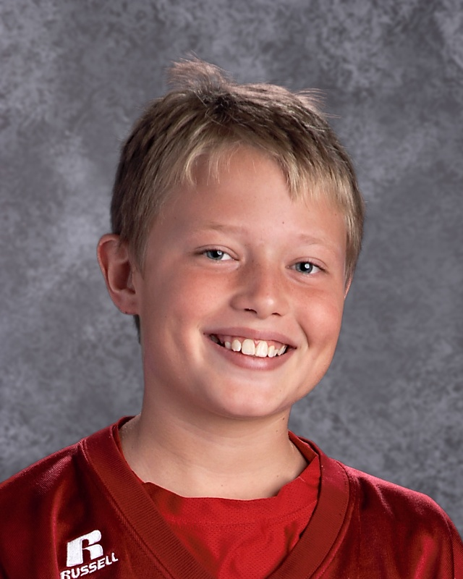

Brewster 7th Grader Joseph Myers has been selected and will be attending the Junior National Young Leaders Conference in Washington DC this summer! Joey will be an excellent representation of Brewster Schools and Rural Kansas! Joseph is pictured above.

Upcoming Western Kansas Liberty League Events…..

WKLL JH Track Meet
May 12 – 10am CT in Logan
WKLL HS Track Meet
May 12 – 2pm CT in Logan

Brewster FFA……As this is being written the Brewster FFA chapter is in Manhattan competing in the state FFA Competition. This is an opportunity for our judging teams to show of the skills they have been honing all school year long. Our senior division judging team that is representing Brewster in Manhattan is Grace Oard (Senior), Austin Bear (Junior), and Weston Schmidt (Freshman). In addition we a junior division team also participating. Those members are Samantha Cozza (8th Grade), Colten Palmer (8th Grade), Brandon Kenny (8th Grade), and Ryan Hause (8th Grade). The judging teams have done an excellent job of representing Brewster this year, bringing home several plaques for high team placement. In addition to judging the FFA organization recently just hosted a Oyster fry and work auction. The turnout was great for the event, and the FFA members are very grateful to all of those who continue to support their program.
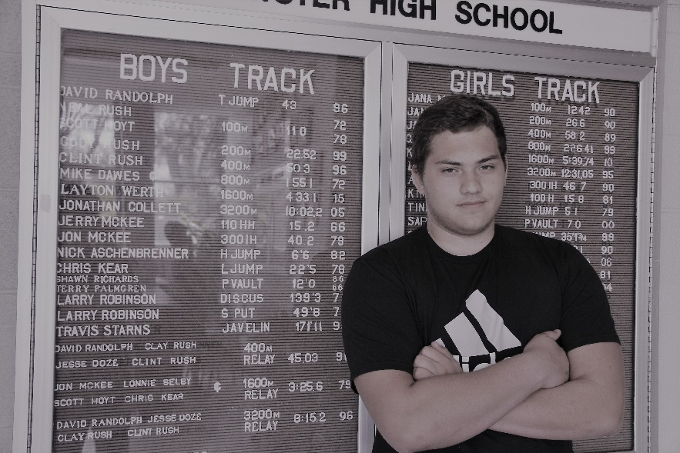
Spring Sports Kicked Off……Both JH and HS track programs have competed well throughout the season. We have had one school record broken so far in the HS men’s discus. Zack Johnson broke a 1971 record held by Larry Robinson with a throw of 140’11”. The previous record was 139’3”. Congratulations to Zack (Pictured Below)! In addition to this broken record, there are several other records “on watch” at both the HS and JH level this year. JH will wrap up their season at Logan on May 12 with the league meet, we wish them the best of luck. HS will finish the regular season in Logan for the WKLL meet as well on the 12th. Continued………

They will look to bring their best performances to the Regional meet the week following in Hays, and hopefully qualify another good contingency of Bulldogs to the State Track and Field meet in Wichita over Memorial Day weekend.
After a year hiatus, Brewster High School once again has a competing golf team. The team is being coached this year by Mr. Michael Collett. While the team consists of some young golfers, they have been performing very well, and competing among the top of the pack in their meets. They will wrap up their regular season Monday May 15 in Hays at the 1A Regional meet. We wish them luck and hope to see a State Qualifier.
Busy, Busy, Busy…….As the end of the school year approaches, our days at school seem to fill up fast with events and activities. Below is an outline of some additional seasonal activities coming up at Brewster Schools………….
May 11 – 6-12 Grade Activities Banquet – Pot Luck Meal 6:45pm, Program 7pm CT
*3rd and 4th Grade Science Projects will be on Display*
May 13 – JH Graduation 10am, HS Baccalaureate 2pm, HS Graduation 4pm
May 16 – K-4th Grade Field Trip to Parrot Cove Water Park in Garden City
May 17 – K-5th Grade Play Day, 8:30am Start
May 18 – Last Day of School, FULL DAY (additional hours are required due to snow day on May 1st)

Classroom Happenings……
High School Math, Mrs. Jessica McCoy…… In Algebra, each student is teaching the class about math they use in their everyday life. Topics have ranged from golf swings to photography. It is great to see how some students view math more positively when they understand it will affect them outside of school.
Geometry students are learning about surface area and volume which will lead to a final project over painting rooms. Juniors have been preparing and taking the ACT this Spring. We spent time in class taking a practice test. Many students are planning on taking a second ACT to improve their scores. I have also been recommending to next year's juniors to plan to take the ACT in the fall.
7-12 Grade Social Studies, Mr. Ray Nolan…… In the Social Studies classes we are covering a wide range of information, from the end of the Cold War to decolonization in Africa after World War II. As for projects, the seventh graders have finished with their Kansas History segment and are working on analyzing the city or state of their choice in coordination with their geography section. They are researching a variety of information including why the city or state exists in the first place and the history of its incorporation and creation. As a class we came up with a variety of questions we have about various areas and the students are analyzing their city or state with those questions in mind. The students will present their findings to the class. The seniors are finishing their sociology class by looking at substance abuse. They are researching several questions including the cost of substance abuse to society and the history of substance abuse in America. We see that substance abuse is not an issue for just the individual, but society as a whole. They also need to come up with solutions to the problem.
3rd Grade, Mrs. Mary Schmidt…… Brewster K-4 elementary students are ending this 2016-2017 school year with a blast of activities. On May 9th we will be celebrating the student’s hard work in Reading with our annual Reading Party. We will play outdoor games at the park by Hunter Hall, ending the day with a special cold treat. Thursday, May 11th, 3rd and 4th graders will be displaying their science experiments at Awards Night. If you cannot make it to Awards Night, the displays will be set up after school for you to see. Tuesday, May 16th, K-4 are going to Parrot Cove Indoor Water Park for a day full of water fun. Remember to send a lunch, towel, and dry clothes with your kids that day. Play Day is scheduled for May 17th in the morning. We encourage parents and families to come watch the kids participate in fun activities. That brings us to May 18th, the last day of school. Thank you parents for your kindness and support this year. Have a great summer!!

Congratulations are in Order!!
The Brewster Music Department has had a busy spring! The High School Choir competed at the Winter Park Ski Music Festival in Winter Park, Colorado in March and came home with two trophies for Superior Ratings and Best in Class! What a great way to be rewarded for their hard work this year! The Choir worked hard to raise the funds to be able to attend this competiton. Great Work Choir and Ms. Chambers! Choir members are pictured to the right holding their trophies! In addtion to the Winter Park competition both Junior High and High School students participated in solo and ensemble festivals in April, earning several outstanding and excellent ratings. Those students will receive their certificates at the Spring Awards Banquet on May 11th. And our Spring Concerts were a big hit with students and parents alike with the country music theme! I am so proud of the growth of these young musicians over the last two years! If you or your student is interested in summer music lessons, please let me know! I'd love to help them continue learning and growing over the summer months!

Some Spring Snapshots……
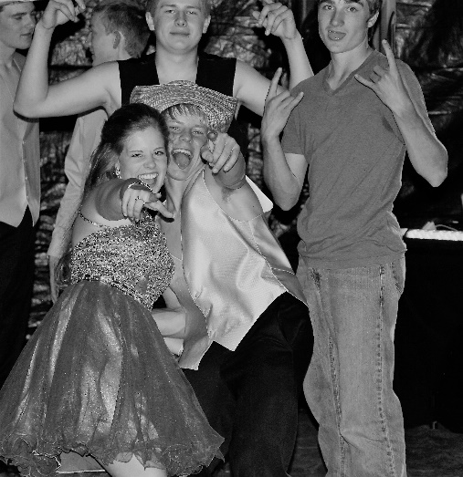

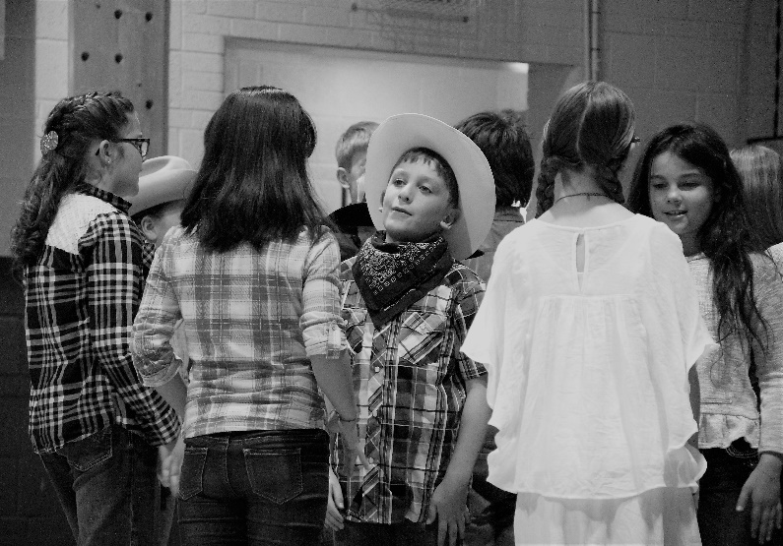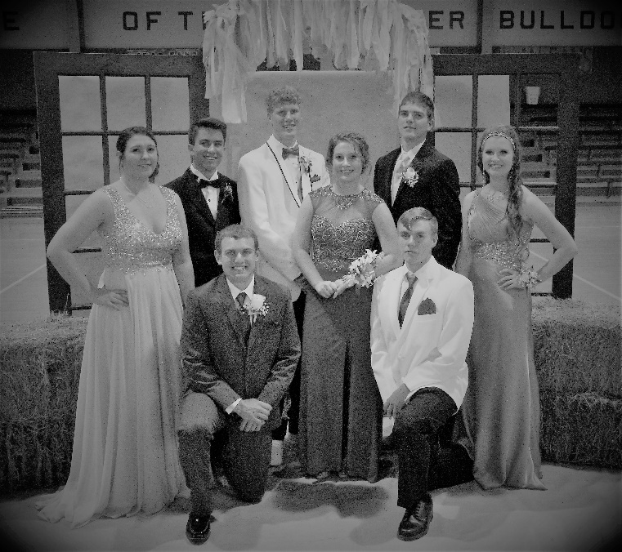

Top Right: 3rd-4th Graders at Shrine Circus
Top Left: Sophomores Enjoy the 2017 Prom, “Rustic Romance”
Bottom Right: Elementary Students Performing a Line Dance at the Spring Concert
Bottom Left: Senior Class at Prom

Contact Information:
Brewster Schools – PO Box 220 – Brewster KS 67732
Phone: 785-694-2236
Fax: 785-694-2746
Web: www.usd314.weebly.com
Superintendent/PK-12 Principal: Shea Rothchild, shea.rothchild@usd314.com
Secretary: Kathy Fulwider, kathy.fulwider@usd314.com
District Clerk: Tarra Baumfalk, tarra.baumfalk@usd314.com
Activities Director: Michael Collett, michael.collett@usd314.com
Transportation Director: Len Cloyd, len.cloyd@usd314.com
Mission Statement:
Working Together, We will establish within a safe and caring environment, a place where students gain knowledge, grow in wisdom and develop confidence while building a strong foundation for lifelong learning and civic responsibility.

